Of course! Designing a microservices-based system using Domain-Driven Design (DDD) and Hexagonal Architecture is an excellent choice for a complex domain like medical clinic administration. It promotes maintainability, scalability, and a clear separation of concerns.
Here is a comprehensive set of design artifacts for your solution, built with Spring Boot in mind.

1. High-Level Architecture: Bounded Contexts & Context Map
First, we apply DDD's strategic design to break down the large, complex domain of "clinic administration" into smaller, more manageable Bounded Contexts. Each Bounded Context will become a microservice.

1.1. Identified Bounded Contexts (Microservices)
- Patient Management Context: Manages all patient-related information, such as demographics, contact details, and registration. This is the authoritative source for patient data.
- Scheduling Context: Handles everything related to appointments, including booking, rescheduling, cancellations, and managing provider availability.
- Billing Context: Responsible for creating invoices, processing payments, and managing insurance details after a clinical service is rendered.
- Clinical Context: Manages the medical aspects of a patient visit, such as consultation notes, diagnoses, and prescriptions.
- Identity & Access Context: A supporting service that handles authentication and authorization for all users (patients, doctors, staff).
- Notifications Context: A generic service responsible for sending communications like appointment reminders or payment confirmations via email or SMS.

1.2. Context Map
The Context Map illustrates the relationships and communication patterns between these Bounded Contexts.
- Shared Kernel (SK): A shared library containing common code, like PatientId or AppointmentId, used by multiple services.
- Customer-Supplier (C/S): One context (the customer) depends on another (the supplier). The Scheduling context is a customer of the Patient Management context to get patient details.
- Open Host Service (OHS) / Published Language (PL): Each context exposes its capabilities through a well-documented API (the Open Host Service) using a clear data schema (the Published Language). REST APIs are a common implementation.
- Anti-Corruption Layer (ACL): When a downstream context wants to protect its domain model from the complexities of an upstream context, it implements an ACL. For example, the Billing context might have an ACL to translate AppointmentCompleted events from the Scheduling context into its own internal language.

2. Deep Dive: The "Scheduling" Microservice
Let's focus on the Scheduling microservice to detail its internal design using DDD tactical patterns and Hexagonal Architecture.

2.1. DDD Tactical Design Artifacts
The core of our service is the domain model, which is pure, business-focused code with no infrastructure dependencies.
- Aggregate: Appointment
  - An Aggregate is a cluster of domain objects (Entities, Value Objects) that can be treated as a single unit. The Appointment is the perfect candidate.
- Aggregate Root: Appointment
  - The Aggregate Root is the single entry point to the aggregate. All external references must go through it. It is responsible for maintaining the integrity and invariants of the entire aggregate.
- Entities within the Aggregate:
  - Appointment: The root entity.
- Value Objects within the Aggregate:
  - AppointmentId: A unique identifier.
  - PatientInfo: A snapshot of patient data (PatientId, name) needed for the appointment. This prevents a synchronous call to the Patient service just to display basic info.
  - TimeSlot: The start and end time of the appointment.
  - AppointmentStatus: An enum (e.g., SCHEDULED, CONFIRMED, COMPLETED, CANCELLED).
- Domain Events:
  - These capture significant business events that have occurred.
  - AppointmentScheduledEvent: Fired when a new appointment is successfully booked.
  - AppointmentRescheduledEvent: Fired when an appointment's time is changed.
  - AppointmentCancelledEvent: Fired when an appointment is cancelled.
  - AppointmentCompletedEvent: Fired when a doctor marks the appointment as finished. This is a crucial trigger for the Billing context.
- Repository Interface:
  - Defines the contract for persistence, living inside the domain model. The implementation, however, is an infrastructure concern.
  - AppointmentRepository: save(Appointment), findById(AppointmentId), findByProviderAndDate(...).

2.2. Hexagonal Architecture (Ports & Adapters)
This architecture protects the domain model from outside concerns.
- Inside the Hexagon (The Application Core):
  - Domain Model: The DDD artifacts described above (Appointment aggregate, etc.).
  - Application Services (Use Cases): Orchestrates the domain logic. It's the primary entry point for any user-driven action. Examples: ScheduleNewAppointmentUseCase, CancelAppointmentUseCase.
  - Ports (Interfaces):
    - Driving/Inbound Ports: These are the APIs of the application core. They are implemented by the Application Services (Use Cases).
    - Driven/Outbound Ports: These are the requirements of the application core for outside functionality (e.g., persistence, messaging). The AppointmentRepository and a hypothetical DomainEventPublisher interface are outbound ports.
- Outside the Hexagon (Infrastructure):
  - Driving/Inbound Adapters: These adapters drive the application by calling the inbound ports.
    - AppointmentController (REST API Adapter): Translates incoming HTTP requests into calls to the Application Services.
    - MessageListener (Messaging Adapter): Listens for asynchronous messages (e.g., ProviderScheduleChanged) and calls the appropriate Application Service.
  - Driven/Outbound Adapters: These adapters are driven by the application; they implement the outbound port interfaces.
    - JpaAppointmentRepository (Database Adapter): Implements the AppointmentRepository interface using Spring Data JPA to talk to a database.
    - KafkaEventPublisher (Messaging Adapter): Implements a DomainEventPublisher interface to send domain events to a Kafka topic.

3. Spring Boot Implementation & Package Structure
Here is a recommended package structure and code examples that align with this design.

3.1. Package Structure
plaintext
com.clinic.scheduling
├── application
│ ├── port
│ │ ├── in
│ │ │ └── ScheduleNewAppointmentUseCase.java
│ │ └── out
│ │ ├── AppointmentRepository.java
│ │ └── DomainEventPublisher.java
│ └── service
│ └── AppointmentService.java // Implements the UseCase interfaces
├── domain
│ ├── model
│ │ ├── Appointment.java // Aggregate Root
│ │ ├── AppointmentStatus.java // Enum
│ │ └── TimeSlot.java // Value Object
│ └── event
│ └── AppointmentScheduledEvent.java
├── infrastructure
│ ├── adapter
│ │ ├── in
│ │ │ └── web
│ │ │ └── AppointmentController.java
│ │ └── out
│ │ ├── persistence
│ │ │ ├── jpa
│ │ │ │ ├── SpringAppointmentRepository.java // Spring Data interface
│ │ │ │ └── JpaAppointmentRepository.java // Adapter implementation
│ │ │ └── entity
│ │ │ └── AppointmentEntity.java // JPA @Entity
│ │ └── messaging
│ │ └── KafkaEventPublisher.java
│ └── config
│ └── BeanConfiguration.java // Spring configuration
└── SchedulingApplication.java

3.2. Code Examples
Here are some illustrative code snippets.
Domain Model (The Core)
This code has zero Spring or persistence annotations. It's pure Java.
java
// domain/model/Appointment.java
public class Appointment {
private AppointmentId id;
private PatientInfo patientInfo;
private ProviderId providerId;
private TimeSlot timeSlot;
private AppointmentStatus status;
private List<DomainEvent> domainEvents = new ArrayList<>();

// Private constructor to enforce creation via factory method
private Appointment() {}

public static Appointment schedule(AppointmentId id, PatientInfo patient, ProviderId provider, TimeSlot slot) {
// Business rule enforcement (invariants)
if (patient == null || provider == null || slot == null) {
throw new IllegalArgumentException("Cannot schedule appointment with missing data.");
}
Appointment appointment = new Appointment();
appointment.id = id;
appointment.patientInfo = patient;
appointment.providerId = provider;
appointment.timeSlot = slot;
appointment.status = AppointmentStatus.SCHEDULED;

// Register a domain event
appointment.registerEvent(new AppointmentScheduledEvent(appointment.id, appointment.patientInfo, appointment.timeSlot));
return appointment;
}

public void confirm() {
if (this.status != AppointmentStatus.SCHEDULED) {
throw new IllegalStateException("Only a scheduled appointment can be confirmed.");
}
this.status = AppointmentStatus.CONFIRMED;
}

public void cancel(String reason) {
if (this.status == AppointmentStatus.COMPLETED) {
throw new IllegalStateException("Cannot cancel a completed appointment.");
}
this.status = AppointmentStatus.CANCELLED;
this.registerEvent(new AppointmentCancelledEvent(this.id, reason));
}

// Getters, registerEvent, clearEvents...
}
Application Service (The Use Case Orchestrator)
This service uses the domain model to perform a task.
java
// application/service/AppointmentService.java
@Service // or @Component
@RequiredArgsConstructor // Lombok for constructor injection
public class AppointmentService implements ScheduleNewAppointmentUseCase {

private final AppointmentRepository appointmentRepository;
private final DomainEventPublisher eventPublisher;
// Could also inject a service to fetch Patient/Provider details

@Override
@Transactional
public AppointmentId scheduleNewAppointment(ScheduleCommand command) {
// 1. Business logic/validation (e.g., check provider availability)
// ...

// 2. Use the domain model's factory method to create the aggregate
Appointment newAppointment = Appointment.schedule(
appointmentRepository.nextId(), // Let repository generate ID
command.getPatientInfo(),
command.getProviderId(),
command.getTimeSlot()
);

// 3. Persist the new aggregate state
appointmentRepository.save(newAppointment);

// 4. Publish domain events
eventPublisher.publish(newAppointment.getDomainEvents());
newAppointment.clearDomainEvents();

return newAppointment.getId();
}
}
Inbound Adapter (The Web Controller)
This is the entry point from the outside world (e.g., a frontend application).
java
// infrastructure/adapter/in/web/AppointmentController.java
@RestController
@RequestMapping("/api/v1/appointments")
@RequiredArgsConstructor
public class AppointmentController {

private final ScheduleNewAppointmentUseCase scheduleNewAppointmentUseCase;

@PostMapping
public ResponseEntity<String> scheduleAppointment(@RequestBody ScheduleRequestDto request) {
// 1. Translate DTO to a use case command
ScheduleCommand command = new ScheduleCommand(
new PatientInfo(request.getPatientId(), request.getPatientName()),
new ProviderId(request.getProviderId()),
new TimeSlot(request.getStartTime(), request.getEndTime())
);

// 2. Call the use case
AppointmentId newAppointmentId = scheduleNewAppointmentUseCase.scheduleNewAppointment(command);

// 3. Return response
return ResponseEntity.created(URI.create("/api/v1/appointments/" + newAppointmentId.getValue()))
.body("Appointment created with ID: " + newAppointmentId.getValue());
}
}
Outbound Adapter (The Persistence Layer)
This adapter implements the repository port using Spring Data JPA.
java
// infrastructure/adapter/out/persistence/jpa/JpaAppointmentRepository.java
@Repository
@RequiredArgsConstructor
public class JpaAppointmentRepository implements AppointmentRepository {

private final SpringAppointmentRepository springRepo; // The Spring Data interface
private final AppointmentMapper mapper; // Maps between domain model and JPA entity

@Override
public void save(Appointment appointment) {
AppointmentEntity entity = mapper.toEntity(appointment);
springRepo.save(entity);
}

@Override
public Optional<Appointment> findById(AppointmentId appointmentId) {
return springRepo.findById(appointmentId.getValue())
.map(mapper::toDomain);
}
// ... other methods
}
This complete structure provides a robust, scalable, and highly maintainable foundation for your medical clinic administration solution.

Of course. An Anti-Corruption Layer (ACL) is a critical pattern in a microservices architecture. Its primary job is to protect your service's core domain model from being "corrupted" by the language and data structures of other services.
In our scenario, the Billing Service doesn't think in terms of "Appointments." It thinks in terms of "Invoices," "Line Items," and "Chargeable Services." The ACL acts as a translator between the Scheduling context and the Billing context.
The ACL will be an inbound adapter in the Billing service's Hexagonal Architecture. It will listen for an event from the Scheduling service (like AppointmentCompletedEvent) and translate it into a command that the Billing service's application core can understand.
Let's build the code for this.

1. The Upstream Event (from the Scheduling Service)
First, let's define the event that the Scheduling service publishes. This is its "Published Language." The Billing service will have a copy of this DTO to understand the incoming message.
java
// This DTO would be in a shared library or defined within the Billing service
// to represent the contract from the Scheduling service.

package com.clinic.billing.infrastructure.adapter.in.messaging.dto;

import java.math.BigDecimal;
import java.time.Instant;
import java.util.List;
import java.util.UUID;

// This is the Data Transfer Object representing the event from the upstream service.
public record AppointmentCompletedEvent(
UUID appointmentId,
UUID patientId,
UUID providerId,
Instant completionTime,
List<ServiceCode> performedServices
) {
// A record representing a billable service performed during the appointment.
public record ServiceCode(String code, String description, BigDecimal standardFee) {}
}

2. The Billing Service's Core Domain
Before building the ACL, we need to know what the ACL is protecting. Here is a simplified version of the Billing service's domain and application layers.

Billing Use Case Command
This is the command the ACL will create. It's part of the Billing service's own language.
java
// com/clinic/billing/application/port/in/CreateInvoiceCommand.java

package com.clinic.billing.application.port.in;

import java.math.BigDecimal;
import java.util.List;
import java.util.UUID;

// A command object that represents the intent to create an invoice.
// This is part of the Billing service's internal API (its inbound port).
public record CreateInvoiceCommand(
UUID patientId,
UUID sourceAppointmentId,
List<LineItem> lineItems
) {
public record LineItem(String serviceCode, String description, BigDecimal amount) {}
}

Billing Use Case Interface (Inbound Port)
java
// com/clinic/billing/application/port/in/CreateInvoiceUseCase.java

package com.clinic.billing.application.port.in;

import com.clinic.billing.domain.model.InvoiceId;

public interface CreateInvoiceUseCase {
InvoiceId createInvoiceFromAppointment(CreateInvoiceCommand command);
}

3. The Anti-Corruption Layer (ACL) Implementation
Now, we'll create the ACL itself. It consists of two main parts: the Listener (which receives the external event) and the Translator (which performs the conversion).

ACL Translator
This component is responsible for the explicit translation from the upstream context's language to our internal domain's language.
java
// com/clinic/billing/infrastructure/adapter/in/messaging/SchedulingEventTranslator.java

package com.clinic.billing.infrastructure.adapter.in.messaging;

import com.clinic.billing.application.port.in.CreateInvoiceCommand;
import com.clinic.billing.infrastructure.adapter.in.messaging.dto.AppointmentCompletedEvent;
import org.springframework.stereotype.Component;

import java.util.stream.Collectors;

/**
* The Translator part of the Anti-Corruption Layer.
* Its sole responsibility is to convert an event from the upstream
* Scheduling context into a command that the local Billing context understands.
*/
@Component
public class SchedulingEventTranslator {

public CreateInvoiceCommand toCreateInvoiceCommand(AppointmentCompletedEvent event) {
if (event == null || event.patientId() == null || event.performedServices() == null) {
// Add robust validation and error handling
throw new IllegalArgumentException("Received invalid AppointmentCompletedEvent data.");
}

var lineItems = event.performedServices().stream()
.map(serviceCode -> new CreateInvoiceCommand.LineItem(
serviceCode.code(),
serviceCode.description(),
serviceCode.standardFee()
))
.collect(Collectors.toList());

return new CreateInvoiceCommand(
event.patientId(),
event.appointmentId(),
lineItems
);
}
}

ACL Message Listener (The Adapter)
This is the infrastructure component that listens to the message queue (e.g., Kafka or RabbitMQ) and orchestrates the translation and execution.
java
// com/clinic/billing/infrastructure/adapter/in/messaging/AppointmentEventListener.java

package com.clinic.billing.infrastructure.adapter.in.messaging;

import com.clinic.billing.application.port.in.CreateInvoiceUseCase;
import com.clinic.billing.infrastructure.adapter.in.messaging.dto.AppointmentCompletedEvent;
import lombok.RequiredArgsConstructor;
import lombok.extern.slf4j.Slf4j;
import org.springframework.kafka.annotation.KafkaListener;
import org.springframework.messaging.handler.annotation.Payload;
import org.springframework.stereotype.Component;

/**
* The Adapter part of the Anti-Corruption Layer.
* This is an inbound adapter that listens for messages from the Scheduling service.
* It drives the application core by invoking a use case.
*/
@Slf4j
@Component
@RequiredArgsConstructor
public class AppointmentEventListener {

private final CreateInvoiceUseCase createInvoiceUseCase;
private final SchedulingEventTranslator translator;

@KafkaListener(topics = "scheduling.appointments.completed", groupId = "billing_service")
public void handleAppointmentCompleted(@Payload AppointmentCompletedEvent event) {
log.info("Received AppointmentCompletedEvent for appointment ID: {}", event.appointmentId());

try {
// 1. Translate the external event into an internal command using the ACL's translator.
var command = translator.toCreateInvoiceCommand(event);

// 2. Invoke the application's use case with the translated command.
// The listener knows nothing about how an invoice is created; it only
// knows how to delegate to the application core.
createInvoiceUseCase.createInvoiceFromAppointment(command);

log.info("Successfully processed event and initiated invoice creation for appointment ID: {}", event.appointmentId());

} catch (Exception e) {
// Implement a robust error handling strategy, e.g., sending to a dead-letter queue (DLQ).
log.error("Failed to process AppointmentCompletedEvent for appointment ID: {}", event.appointmentId(), e);
}
}
}

Summary of the ACL's Role
- Listens for External Events: The AppointmentEventListener subscribes to a topic where another service publishes its events.
- Isolates External Models: The AppointmentCompletedEvent DTO is confined to the infrastructure layer. It never leaks into the application or domain packages.
- Translates Explicitly: The SchedulingEventTranslator performs a clean, explicit conversion from the external DTO to the internal CreateInvoiceCommand. This protects the Billing domain from changes in the Scheduling domain. If the Scheduling service adds a new field to its event, only the translator and the DTO need to change, not the core business logic.
- Drives the Application Core: After translation, the listener calls the CreateInvoiceUseCase port, driving your application just like a REST controller would, but in response to an asynchronous event.
This design creates a strong boundary, ensuring the Billing service remains autonomous, resilient to upstream changes, and focused on its own business responsibilities.

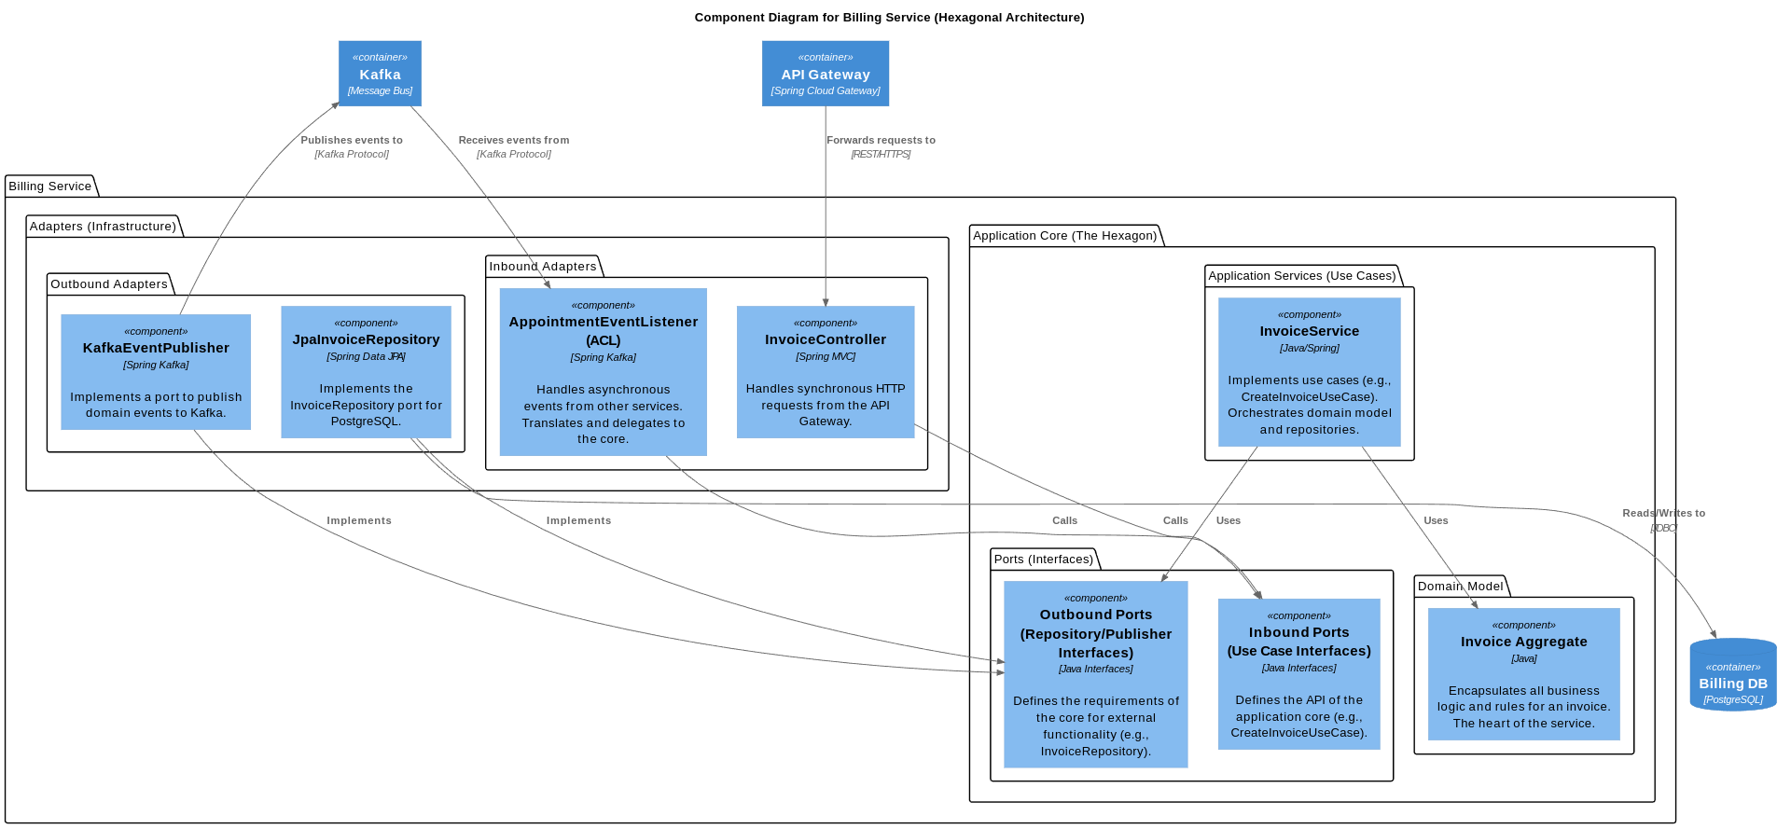
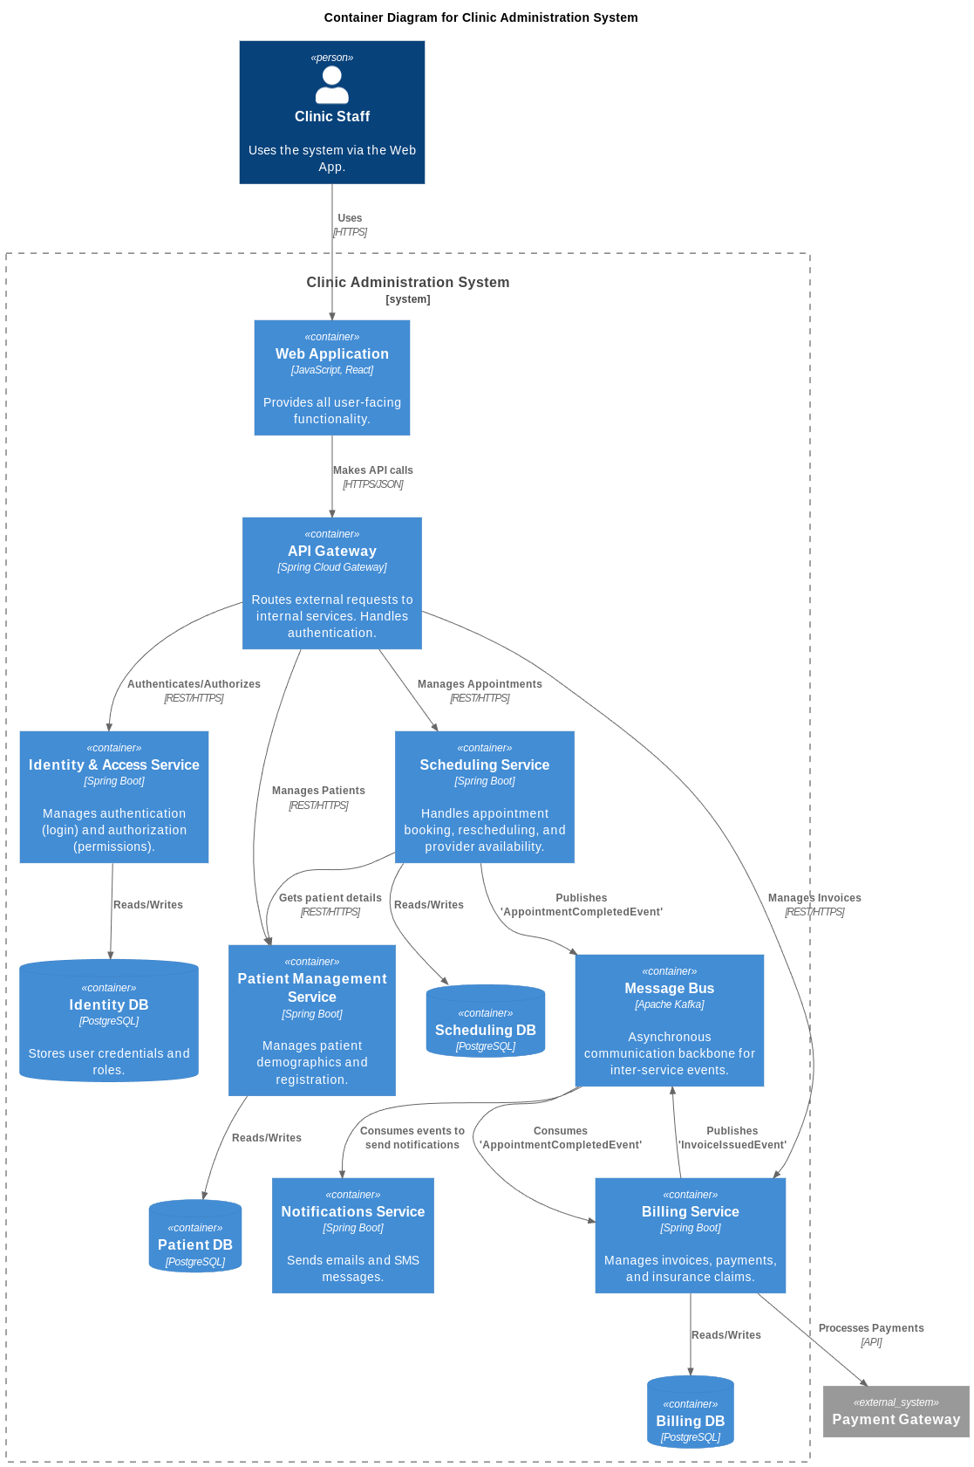

2. PostgreSQL Initialization Script
The docker-compose.yml file references an initialization script to create the databases for your services. You need to create this script as well.
Create the following directory structure and file:
plaintext
.
├── docker/
│ └── postgres/
│ └── init-multiple-databases.sh
└── docker-compose.yml
Here is the content for the init-multiple-databases.sh file:
New file: init-multiple-databases.sh
+18
#!/bin/bash
set -e

psql -v ON_ERROR_STOP=1 --username "$POSTGRES_USER" --dbname "$POSTGRES_DB" <<-EOSQL
-- Create databases for each microservice as per the architecture
CREATE DATABASE identity_db;
CREATE DATABASE patient_db;
CREATE DATABASE scheduling_db;
CREATE DATABASE billing_db;
-- The notification service might not need a DB, but we can add one if needed
-- CREATE DATABASE notification_db;

-- Grant all privileges on these new databases to the admin user
GRANT ALL PRIVILEGES ON DATABASE identity_db TO admin;
GRANT ALL PRIVILEGES ON DATABASE patient_db TO admin;
GRANT ALL PRIVILEGES ON DATABASE scheduling_db TO admin;
GRANT ALL PRIVILEGES ON DATABASE billing_db TO admin;
EOSQL

Note: On Linux or macOS, you may need to make the script executable by running chmod +x docker/postgres/init-multiple-databases.sh.

How to Run
With both files in place, you can start your entire local infrastructure with a single command from the root of your project:
sh
docker-compose up -d
This will start PostgreSQL and Kafka in the background. Your Spring Boot applications, when launched from VS Code, can now connect to localhost:5432 for the database and localhost:29092 for Kafka.

Of course! Configuring your Spring Boot services to connect to the Docker-based infrastructure is a crucial step. Here is a detailed guide and the necessary configuration code.

Core Concept
Your Spring Boot applications will run directly on your host machine (e.g., when you launch them from VS Code), while the database and message broker run inside Docker containers. The docker-compose.yml file exposes ports from the containers to your host machine.
- PostgreSQL: The container's port 5432 is mapped to your host's port 5432.
- Kafka: The container's port 29092 is mapped to your host's port 29092.
Therefore, your applications can connect to these services by pointing to localhost on the respective exposed ports.

Configuration for Spring Boot Services
You need to configure each microservice's application.yml (or application.properties) file. The most important part is ensuring each service connects to its own database (as created by your init-multiple-databases.sh script) and runs on a unique server port to avoid conflicts.
Here is a complete example for the Billing Service. You would place this file in its resource directory (billing-service/src/main/resources/application.yml).
New file: application.yml
+28
# Server Configuration: Each service must have a unique port.
server:
port: 8083

# Spring Application Name
spring:
application:
name: billing-service

# ------------------ Datasource Configuration ------------------
# Connects to the PostgreSQL container running via Docker Compose.
datasource:
url: jdbc:postgresql://localhost:5432/billing_db
username: admin
password: password
driver-class-name: org.postgresql.Driver

# ------------------ JPA / Hibernate Configuration ------------------
jpa:
hibernate:
ddl-auto: validate # Use 'validate' in dev to ensure entities match schema. Use 'none' in prod.
show-sql: true

# ------------------ Kafka Configuration ------------------
kafka:
bootstrap-servers: localhost:29092
consumer:
group-id: billing_service # Unique group ID for this consumer

Configuration for All Services
To get your entire system running, you must apply a similar configuration to each service, making sure to change the server.port and the database name in the spring.datasource.url.
Here is a summary of the key properties for each service:
Service Name | server.port | spring.datasource.url
API Gateway | 8080 | (No database needed)
Identity Service | 8081 | jdbc:postgresql://localhost:5432/identity_db
Patient Service | 8082 | jdbc:postgresql://localhost:5432/patient_db
Billing Service | 8083 | jdbc:postgresql://localhost:5432/billing_db
Scheduling Service | 8084 | jdbc:postgresql://localhost:5432/scheduling_db
Notification Service | 8085 | (No database needed, unless you add persistence)
By applying this configuration pattern to each of your microservices, they will be able to connect to the Dockerized infrastructure and run simultaneously on your local machine without any port or database conflicts.

1. C4 Model: System Context Diagram
This diagram uses the official C4-PlantUML library to provide a high-level view of your system and its interactions with users.

